TRIALS LEGENDS

‘Trials Legends’ is a special ‘section’ on Trials Gurudedicated to those people who have made the headlines, won events, won championships and promoted the sport of observed motorcycle trials the world over. Already we have special sections dedicated to individual riders such as: Yrjo Vesterinen, Lampkin of Silsden, Sammy Miller and Rob Edwards which will remain on this website as they are.

Over time we will expand ‘Trials Legends’ to include more personalities from the world of trials.

…

MALCOLM CHARLES RATHMELL:
Words: Sean Lawless – Lawless Media UK –
Photos: Jimmy Young; Iain Lawrie; Mike Rapley; Colin Bullock & Barry Robinson
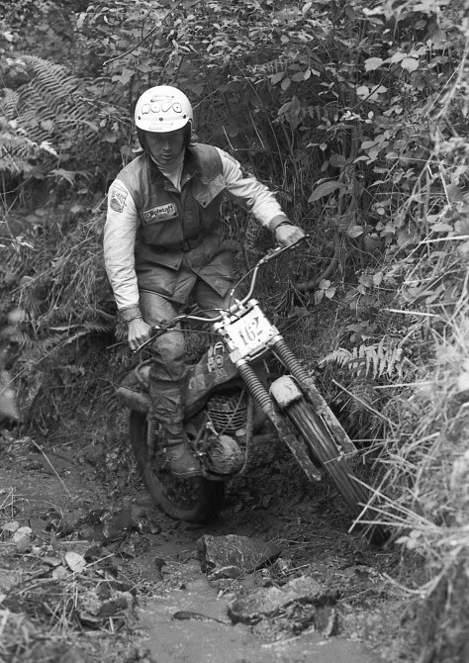Malcolm Charles Rathmell (Montesa) – Photo: Mike Rapley
A life less ordinary – Grands Prix motocrosser, world trials contender, successful businessman and mentor to one of extreme enduros biggest names – Malcolm Rathmell’s influence on off-road sport has been huge (although he’d probably say we’re talking bollocks!)…
Here’s a good one for all you off-road fact fans – who’s the only rider to race motocross grands prix and finish top three in the World Trials Championship?
I’d love to leave you feverishly flicking through piles of yellowing magazines or scouring the internet for an answer but – seeing as the next few thousand words are going to be all about him – there’s not much point.
To someone my age who started riding trials in the late ’70s, Malcolm Rathmell – along with his great friend, rival and sparring partner Martin Lampkin – is a legendary figure. To this day I can’t shake the image of a gloveless Malc, blond hair flowing out of his helmet, oozing style as he cleaned another rocky stream section on his Montesa. If Yorkshiremen did glamour then he was the pin-up boy…
Now 67 years of age and boss of UK Sherco importer MRS, his blond locks may be a distant memory, but he still looks in great shape and is as matter-of-fact as only a Yorkshireman can be.
“Morning Seamus,” he says. “You’re getting a gut on you!”
Cheers Malc! Good to see you too…
There’s a stereotype of Yorkshire people being blunt, straight-talkers – that ‘I say what I bloody well like and like what I bloody well say’ sort of thing – and Malc certainly ticks a lot of boxes in that respect. Not that that’s a bad thing. I’d rather hear an honest opinion than have smoke blown up my arse any day of the week.
“I’m Yorkshire born and bred and proud of it,” he says. “I was born in Otley, lived at Timble, went to school at Fewston which is a village near Timble. Otley School of Learning after that until I was 15 and then joined the Forestry Commission where I did a bit of everything for seven years. Fencing, draining, planting, felling – and it was good for practice. That was the best bit of it. You could spend your lunchtimes on your bike.”
We’re sat in Malc’s office in Bishop Thornton which can’t, as the crow flies, be more than 15 miles from his birthplace. Timble and Fewston are even closer and pretty much everywhere you look is prime trials country. Addingham Moorside and Pately Bridge are nearby, the towns of Yeadon and Guiseley are a stone’s throw away and then there’s Silsden – seat of the Lampkin clan – just down the road.
This is the heartland of UK trials and, born into a motorcycle-mad family, Malc was destined to ride although the path he’d take – trials or motocross – wasn’t as clear cut.
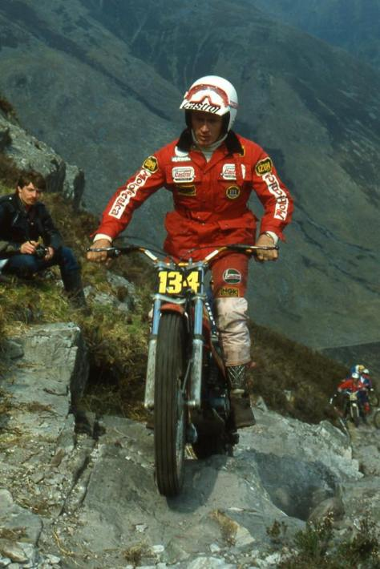Malcolm Rathmell (349 Montesa) in the 1980 Scottish Six Days on Calliach – © – Iain Lawrie, Kinlochleven.
“I’ve not really had a choice – bikes, bikes or bikes! I used to get a bollocking at school because first thing in the morning you had to write about what you did last night and five days a week I wrote ‘I rode my bike last night’. That was it.
“My dad Eric got me a rigid Bantam of my own when I was about nine which I put into scrambles trim and I scrambled that around a field for a couple of years.
“My father started riding local trials after the war and when I was a kid there was always a bike there so I’d siphon petrol out of his car and ride whatever bike was available. He was big mates with [TMX trials correspondent] Barry Robinson and Barry always had a bike or a couple of bikes stood in our spot. We lived in a cottage in the middle of fields and woods so it was ideal for spending time on bikes.
“Half the Ilkley Motor Club used to leave their bikes up at my father’s spot so there was always something there to ride. Whoever was daft enough to leave their bike there with petrol in got it used.”
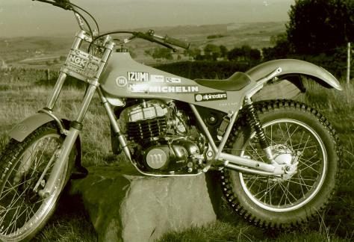Malcolm Rathmell’s factory Montesa Cota 349 in 1982 by ace photographer, Barry Robinson
Eric was heavily involved in the Ilkley club and Malc was roped in at an early age.
“Dad was Clerk of the Course for all the Ilkley events and had a pillion on his Ajay so I spent my younger years doing laps of the Ilkley Grand National course and the Scott course on the back of him carrying a bag of flags. When he stopped I’d run off and stick a flag in.”
I once did say that Graham Jarvis was arguably Britain’s best ever trials rider who doesn’t have the surname Lampkin. However, after running through Malc’s record I reckon I got that wrong!
Malc’s won the British title six times, taken the same number of Scott Trial wins and won the SSDT twice. He was also European champion in 1974 – the year before the series was upgraded to world status – and for seven years, from 1971 to ’77, was never out of the European/world top three. Add to that his 11 world round wins and it’s an impressive tally.
But it was motocross – or scrambling – that a young Malc was most interested in.
“I was more into scrambling and most weekends we went to a local scramble. My dad used to do Tony Cook’s bikes. I think he was Yorkshire Centre champion a couple of years. He used to come up every week and have his bikes done – I think my dad had more interest in scrambles than trials.
“But both my mum and dad insisted that I learned to ride a trials bike because if you can ride a trials bike you can ride any bike. I went from a Bantam to a 150cc Triumph Terrier and then I got a Greeves Hawkstone when I was about 14 or 15. I had my own private scrambles track so I was there every night and Tony Cook used to come up Saturday mornings.”
After a shrewd deal to upgrade his machinery, Malc was then given the chance thanks to Pete Edmondson – father of former world enduro champion Paul – to get his hands on his most competitive bike so far.
“I swapped the two or three bikes I had for a C15 BSA which I rode for about six months and then I got the chance of a Tiger Cub from the brother of a butcher in Otley who helped me a little bit. He’d had a lot of problems with it and it had gone back to the factory because they’d forgot to drill some holes in the crankcases for the oil to return.
“So this came up in Pete Edmondson’s shop in Otley and with it having all these problems it was cheap so I cashed the BSA in for this Tiger Cub. Eddy gave me it on a glad and sorry – glad I bought it, sorry I can’t pay for it – which helped me for six months as I paid for it as we went along.”
Malc made his competition debut in a Bradford centre trial and in his first national – the Clayton Trial – when he was still 16 he beat Sammy Miller, the reigning British champion.
Despite this early success he was still more passionate about scrambling and started racing when he was 17.
“I had some decent rides on the Cub and got a bit of help from Henry Vale at the Triumph factory for a couple of years. In among all this the butcher that I spoke about had a Greeves scrambler which he never hardly rode so he lent me it.”
“At that time you did trials from the Scott to the Scottish and you did scrambles from the Scottish to the Scott. So Eric Atkinson – that was the butcher in Otley – lent me the bike for that summer.”
“You couldn’t ride until you were 16 so I did a full year of trials and then when I was 17 it was half trials and half scrambles and I went all right on this Greeves. Triumph was just finishing then and I needed a trials bike so Pete Eddy said that Bill Brooker down at Greeves was looking for someone up here to ride. We jumped in Eddy’s car, went down to Thundersley and came back with a 250, a 360 and a trials bike. That was a good trip.”
After riding for Greeves in 1968 and ’69, he signed for the Bultaco factory in 1970 for motocross.
“I did my first GP that year in Spain. At that time they only had one bike so they sent it over here for me to use and then for the Spanish Grand Prix I had to fly it back with me as hand baggage to Barcelona. I just wheeled it across the Tarmac. That’s how it was, it was a different world to what it is now. I don’t think I’d even to drain the petrol out of it.
“I didn’t do a full series – some clashed with events like the Scottish – and I did a couple the year after but I was doing mostly trials by then. I rode 250 British championship in 1970 and finished sixth or seventh, I can’t remember.”
Malc didn’t score any GP points but back then they were only paid out to 10th and among his competitors were riders of the calibre of Joel Robert, Sylvain Geboers and Roger De Coster. So while it wasn’t an earth-shattering debut it was a firm foundation to build on – but he was being steered in a different direction.
“It was old man [Francesco] Bulto who got me to change back to trials. Sammy Miller was about to retire and I think Bultaco wanted someone to replace him and because I was riding not bad in trials they picked me.”
What Malc doesn’t mention is that in between racing 250 GPs he also finished that year’s European Trials Championship in fifth, despite only competing in three rounds.
So for 1971 he alternated between motocross and trials – with plenty of success in both disciplines – before returning to trials full-time in 1972.
“My best scrambles results at that time were two thirds at one meeting in the British championship and I’d also won a couple of national trials. I suppose it was 50/50. My results were probably a bit better in trials but scrambling was more enjoyable. I should probably have continued with scrambling. With trials it happens, with scrambling you make it happen. Who knows?”
Malc was second in the 1971 Euro trials series. The same year he won the British Experts with a broken wrist sustained at the Scott Trial – where he’d also broken his ankle – and carried this form into the 1972 season when he was again second in Europe and claimed his first British title.
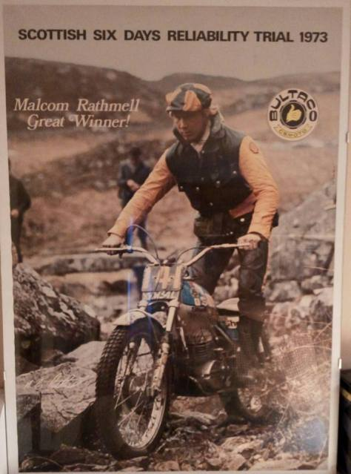SSDT winner in 1973, Bultaco Motorcycles made full use of the win to publicise their product world-wide – Photo: Bultaco Motorcycles
After taking his first SSDT win he slipped to third in Europe in 1973 and tried to get out of his Bultaco contract in favour of another iconic Spanish marque. Fortunately he failed and went on to win the European Trials Championship – “it was actually the Euro/American championship, the only one ever” – and begin a run of three consecutive British trials titles.
“I nearly changed [in ’74] because I’d been approached by Ossa that year but I did have a three-year deal with Bultaco. It was a very vague sort of deal – more of a handshake. I did have a bit on paper and it was only right that I stayed there in the end. I did try to get out of the contract but, fair enough, luckily it didn’t work because I went on to have a great year with Bultaco and left them to go to Montesa on good terms.”
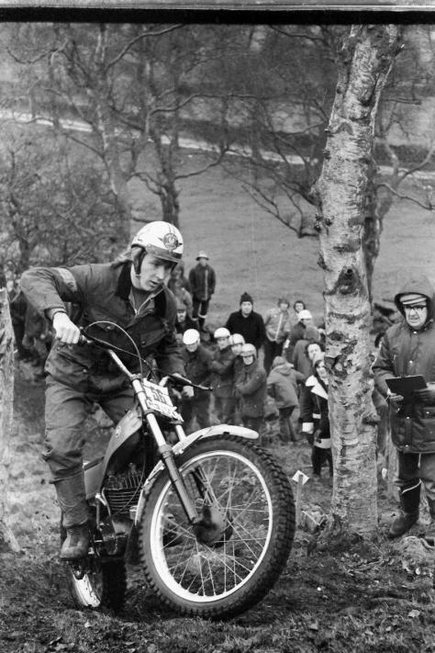Malcolm Rathmell in the 1975 Jack Leslie Ellis Trial on the prototype 348 Montesa. Photo copyright: Barry Robinson
Malc’s switch to Montesa wasn’t widely regarded as a smart move but his experience, talent and technical knowledge made him an ideal choice for the Spanish factory as it looked to expand its range of machinery.
“I started in ’75 on Montesa with the late Jim Sandiford. The job was to make the Montesa better. I went there as a development rider on the understanding that they didn’t have a bike – they had a 250 but they didn’t have a big one – so my job was to make a bike.
“I spent quite a lot of time down in Spain and we worked with five and six-geared versions. I rode with six gears all year until the last round.”
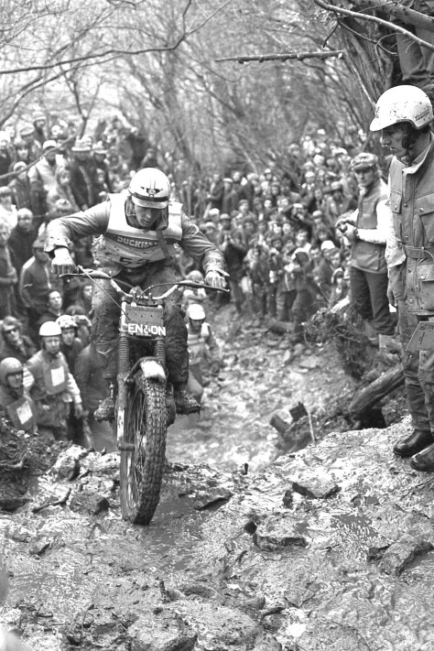Malcolm Rathmell (Montesa) watched by Brian Higgins at the World Championship trial, Bristol in 1975 – Photo: Mike Rapley
The last round of the first-ever world championship was unbearably tense. For its inaugural year the series had visited 14 different countries but riders could drop their six worst scores and coming into the Czecho finale it was between Malc, Mart Lampkin and Yrjo Vesterinen.
Malc had won three rounds, so had Mart and Vesty had won four. The title was balanced on a knife edge but the Montesa factory had a surprise in store for its star rider.
“Pedro Pi was team manager then. They insisted on taking the bike back after Germany to go through it. I’d ridden the six-speed all year but they brought it back for Czecho and they’d put a five-speed box in it.”
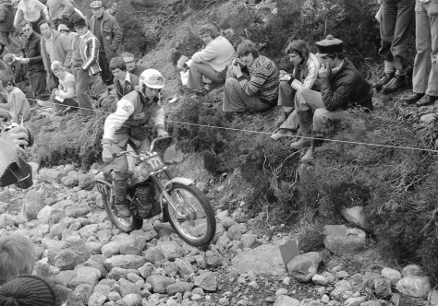Malcolm Rathmell (Montesa) on Laggan Locks in 1977 SSDT – Photo: Iin Lawrie, Kinlochleven
Mick Andrews won the trial with Malc and Mart tied for second. When the number of cleans were counted Mart just edged it which gave him the title.
“I don’t know if they’d brought the normal bike back whether I’d have won it or I wouldn’t have won it – it’s no excuse, it was the same bloody bike anyway. We had the fastest trip back from Czecho ever – we were home for breakfast!”
Malc’s still got four prototypes with different frames, engines and gearboxes that eventually became the production 348. Montesa’s decision to hand him a five-speed version for the final round may or may not have been flawed but its choice of development rider certainly wasn’t and the 348 became the biggest-selling trials bike of all time.
After staying with Montesa in ’76 and ’77 – finishing second and third in the world – he was lured away to join Suzuki and became the highest paid trials rider in the world. Unfortunately, the bike wasn’t nearly as good as the pay cheque…
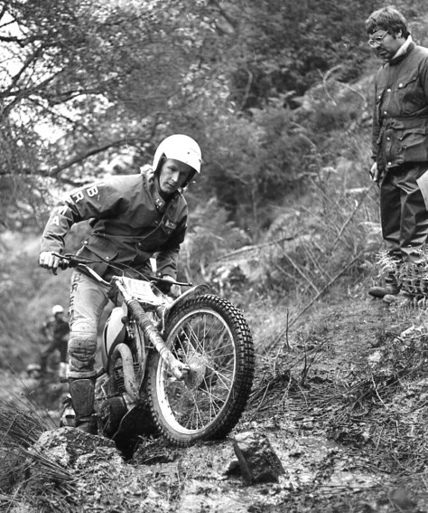Malcolm Rathmell in full control of the Suzuki, which he found uncompetitive – Photo: Mike Rapley
“In 1978 they wanted someone to ride Suzuki and I suppose everyone was hoping the Japanese were going to come in with a trials bike. Kawasaki were trying at the time and Honda so the Japanese were having a go and it was an opportunity to be involved with it.”
Suzuki importer Graham Beamish handled the two-year contract which had a one-year get-out clause on both sides and, after a season that saw Malc slip to 14th in the world, both parties were thankful for it.
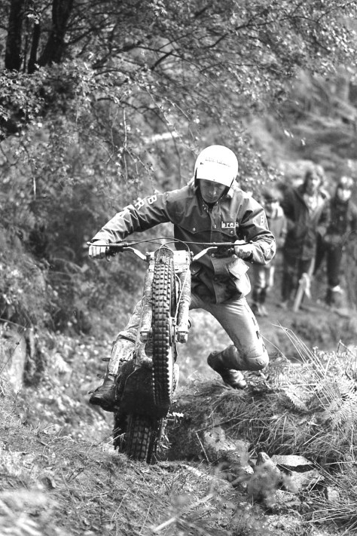Malcolm Rathmell on the Beamish Suzuki takes a flying dab – Photo: Mike Rapley
“We worked with Mick Whitlock to try and sort the frame out. Everything was wrong with it to be honest but having worked with Montesa I knew there was nothing that couldn’t be put right if we’d had the gear.
“With Mick we made new swinging arms, new frames – changed all the geometry. We copied a Montesa frame and god knows what else but it just didn’t work together with the engine and to get stuff done for the engine was impossible but Graham was absolutely brilliant and we remained good mates long after that.”
Used to working with a European manufacturer, Malc found himself becoming increasingly frustrated as he struggled to make the Suzuki competitive.
“The biggest problem was I’d been used to slipping over to Barcelona if I needed to do any work on it and with Japan if you wanted something changing it was three months and by then half your championship had gone.
“You went to Barcelona and got the welder out and got the hacksaw out and you did it. The downside was you’d be ready to go training at 9am and the bike wouldn’t be ready. So you’d wait and wait and by 3pm it would be ready – and then everyone would go to lunch! You wouldn’t start your day’s testing until 5pm.
“It’s still the same now – I think that’s just how the Spanish are – but they were great to work with. Just a little bit different from Yorkshire.”
So for 1979 he went from being the world’s highest-earning trials rider to one of the lowest…
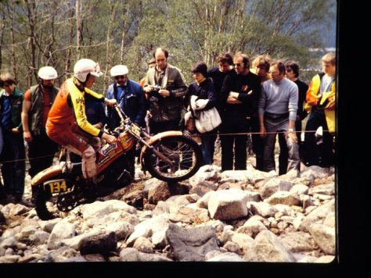1979 Scottish Six Days Trial – Malcolm Rathmell on the 349 Montesa – © -Jimmy Young, Armadale.
“Montesa had taken someone else on so there wasn’t a place but they’d do me a bike and bits and a bonus system. I won the Scottish and some world rounds so I thought it was a good time to sort things out and got another three-year contract with them.”
Finishing fifth in the world, Malc also won his fifth British title but after a decade at the top his star was waning. He won his final British championship in 1981 but slipped out of the world top 10 and needed a back operation. The following year he called it quits, returning once to ride the Scott in 1983 when he finished fifth.
Together with wife Rhoda he bought a hotel in Grassington and prepared to settle into retirement but even if he thought he’d finished with trials, trials hadn’t finished with him.
“The first weekend we opened it was the world trial at Pately Bridge so we were full of riders. We had 42 people staying. We had Bill Wilkinson behind the bar, Don Smith serving on.
“All the Spanish Federation team would come back to stay between the England and Ireland world rounds. We even had Jordi Tarres staying in the car park. They used to ride their Montys around the square and cause havoc.”
Like all sportsman of his calibre, Malc openly admits that throughout his career his prime motivation was winning but his Yorkshire pragmatism kicks in when I ask him whether he regrets not winning the 1975 world championship.
“Not at all,” he replies without a moment’s though. “It doesn’t bother me. I did what I had to do at the time and that was it. What you win you win and what you don’t is gone. I’ve no regrets about that at all. If you don’t do it you don’t do it. It’s your own bloody fault isn’t it…”

Double act!
Malc on Mart…
Malc and Mart, Mart and Malc. To say the pair were the best of mates doesn’t do justice to a profound friendship that lasted for over half-a-century until Mart’s untimely death in April this year.
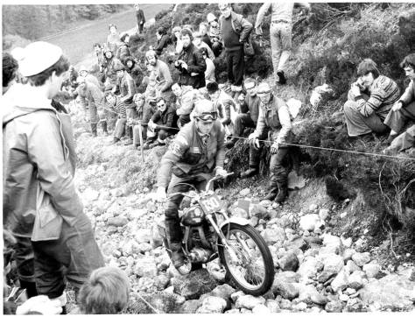Great friend of Malcolm Rathmell was the late Martin Lampkin seen here on his factory Bultaco on Laggan Locks in 1977 at the Scottish Six Days Trial – Photo: Iain Lawrie, Kinlochleven
“We first met in some beck or puddle in the early ’60s when he used to go with ‘Sid’ [Alan Lampkin] and ‘Ping’ [Arthur Lampkin]. He was too young to ride but he used to go with them to local scrambles and I used to go with Tony Cook so we crossed paths. We didn’t really know each other besides mucking about together.”
Their friendship didn’t really start until they began competing in the mid ’60s but their fierce rivalry (motorbikes, dominoes, cricket, darts – you name it, they wanted to beat each other at it) was rooted in mutual respect and, dare I say it about two Yorkshiremen, deep affection. For a time they even went into business together…
“In 1971 we started a coal round. We needed something to do when we weren’t travelling. Trouble was the customers when we were in Spain didn’t think it was a right good idea when they had no coal for three weeks so we had to take a bloke on.
“We did it through one full winter but it was in the summer when we were away that the trouble started. Daftest thing we did was buy another round – we couldn’t do one properly so we thought we’d have another.”
The pair had a totally different approach to riding with Malc’s finesse contrasting with Mart’s bull-in-a-china-shop style but both were hugely successful.
Naturally, as mates do, they also got into a few scrapes along the way and Mart was always the one to spin out a great yarn from their adventures including Dougie’s favourite story about the time the cream of British trials talent decided to stage a boat race.
“We were in the middle of a lake in Finland – Dave Thorpe [not the motocrosser], Rob Edwards, Mart and myself. I was in with Rob and Mart was with Thorpey in these two boats and we rowed out. Thorpey knew I couldn’t swim and had planned with Rob that he’d pull alongside, Rob would pull the bung out and leap in with them and they’d row off.
“Mart had got a 400-18 inner tube that he was sat on so just as the boat was disappearing he was going to chuck me this tube which he did do but only after I was sat there for five minutes waiting for the boat to sink. He was always telling that story, only he could make it last for three hours.”
Malc’s got a few anecdotes of his own, including the time Mart felt the long arm of the Spanish law.
“Me, Sid and Mart were in Barcelona one night and we’d had a few sherbets and were semi-lost trying to find our way back. Me and Sid found a wheelbarrow so I jumped in and Sid started pushing me – next thing I see Mart’s on this pushbike, riding round us singing ‘rain drops keep falling on my head’.
“All of a sudden this copper comes out of a bar, gets his truncheon out and whacks him hard across the back of his head. Mart had nicked his bike!”

Life after riding:
A brief update…
After six years running the hotel Malc and Rhoda were ready for a change.
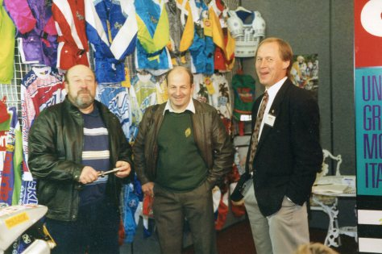Bristol Dirt Bike Show 1991, Jack Mathews, Mike Rapley and Malcolm Rathmell
Malc had stayed involved in the sport, managing the Yorkshire Inter Centre team and in 1989 he was training the ACU’s under 21 team which included Rob Crawford, Steve Colley, Graham Jarvis, Wayne Braybrook, Adam Norris and Rob Warner. His approach was ahead of its time with regular physical evaluations at Liverpool University and a bonus system for riders.
Then, at the 1990 British world round at Merthyr, he was approached by an Italian with a proposition that would change the course of his life.
“I came out of the hotel about seven o’clock in the morning and this bloke got hold of me and said ‘are you interested to do Aprilia?’. They were looking for someone to do trials and a little bit of enduro and that’s how we got back into it. We got a few bits of product and then Graham [Jarvis] came to live with us and it all started again.”
Scorpa followed in ’93 and, thanks to this association with Marc Teissier, when the Frenchman revived the famous Bultaco name that quickly evolved into Sherco it was Malc who he wanted on board.

Highlights
The best bits:
The historical importance of the Scott Trial can’t be under-estimated. The time and observation event – the toughest one-day trial in the world – is over 100 years old and Malc has been involved with it for more than half of this period.
From his early days helping his dad mark out the course to winning it six times to helping Graham Jarvis win it a record nine times, the Scott Trial remains close to his heart.
“I think my Scott wins are the highlight of my career. You’ve got to be organised and prepared – if you’re not 100 per cent then forget about it.”
Graham’s trials riding career is briefly documented earlier in this month’s magazine and Malc gets an even briefer mention as his mentor. No insult was intended – the feature is about Graham’s life after trials – but perhaps this is as good a place as any to flesh out their relationship a little.
It’s clear that Malc is very proud of the way his protégé has risen to the top of extreme enduros after moving to Yorkshire to live with the Rathmell family as a teenager.
“Graham stuck it out and there were times that I didn’t think he would. He got some stick but he always came back for more. He was semi-knackered when he left us. He had two knackered knees and a knackered back. I think everything he’s done now he learned from the Scott Trial.”
While Graham undoubtedly benefitted from having Malc in his corner, he also gave Malc the opportunity to once again travel the world with – more often than not – his old mate in tow. He doesn’t mention him by name but I’m guessing Mart’s on his mind as our interview concludes.
“I can honestly say I enjoyed every minute through my riding career and through Graham’s. It was good because I did it all again. It was like we had a second lap of everything.”

Who is Sean Lawless?
Sean spent over a decade editing publications including MXUK, Dirt Bike Rider and Trialsworld magazine.
After moving into event media for, among others, the Red Bull Pro Nationals, Goodwood Action Sports at the Festival of Speed and the Monster Energy Arenacross Tour, Sean turned freelance and is now Motocross Editor for Trials and Motocross News.
A regular contributor to magazines around the world, Sean’s interviewed some of the off-road world’s greats from Dave Thorpe to Ryan Dungey to Yrjo Vesterinen.
Specialising in off-road motorcycle sport, Lawless Media UK is run by Sean Lawless.

This article is the intellectual property and copyright of Sean Lawless/Lawless Media UK

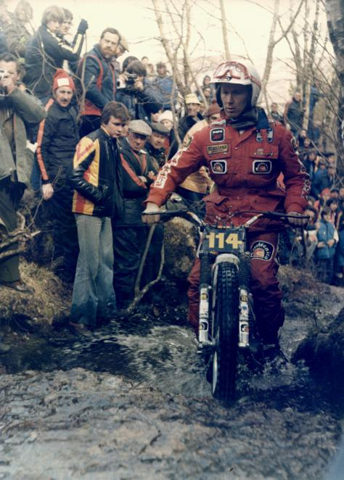Trials Legends – Malcolm Rathmell (Montesa) 1979 SSDT – Photo: Colin Bullock

